Lab 2- Construct a pipeline with the MERGE statement

Estimated completion time
- 30 minutes

Learning objectives
- In this lab, you will construct the building blocks of a data pipeline whose ingestion data represents new and updated records needing to be updated in a Consume layer table. The implementation you will construct is a batch, merged-based data pipeline. It will utilize the MERGE statement as it allows us to not only address new records with a transaction, but also can tackle the updates and deletes of existing records in the same transaction.

Activities
- Review the pipeline dataset
- Review pipeline requirements
- Review initial load dataset
- Simulate initial ingestion to Land layer
- Transform data types
- Perform initial load to Structure layer
- Simulate ingestion of delta records
- Build the pipeline’s MERGE statement
- Verify the MERGE logic
- Next steps

Step 1 - Review pipeline dataset
For this lab, you will use the publicly available Bluebikes - Hubway dataset. Read more information about Blue Bikes Boston, a bicycle-sharing program based in Boston since 2011.

More specifically, you will be focused on the Bluebikes stations, which are the places where the bikes are stored, and rides begin and end as described at https://www.bluebikes.com/system-data.

Step 2 - Review pipeline requirements
Create a data pipeline that will be executed manually with the following high-level requirements broken down by the three layers of the reference architecture.

Land layer
- Creates an ingestion process for the bike trips data, which is:
  - Triggered by the creation of a new dataset.
  - Lands raw data into a working table.
- The land layer defines a location on the data lake to store historical raw data
Structure layer
- Transforms data in the Land layer to produce the new, complete, row-level single source of truth for the dataset.
- Its objective should be:
  - Ensuring data is of high quality
  - Perform casting of datatypes to most the appropriate type.
  - Augment the records by adding the following columns based on the rider's postal code. These include:
    - Province (state for the USA).
    - Average income.

Step 3 - Review initial load dataset
The initial load of station records is from a version dated January 15, 2022. There is no attempt to build the ingestion process at this time, but it can be simulated. Although you can not access S3, there is a directory in the data lake.

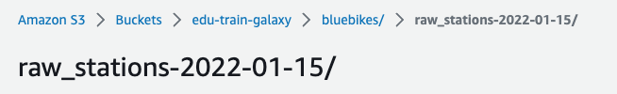

It contains a single file based on the as-of-date identified in the folder above and will be used to establish the first version of this updateable table.

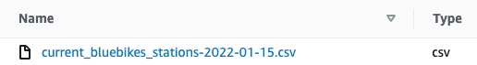

Optionally, you could download the current dataset as from https://s3.amazonaws.com/hubway-data/current_bluebikes_stations.csv, but the lab instructions will use the data already identified above.

Here are a few records from the file above. You will notice there is an extra header line identifying the date the data file was updated. That will be leveraged later in the exercise.

Last Updated,1/15/2022,,,,,,
Number,Name,Lat,Long,District,Public,Total docks,Deployment Year
K32015,1200 Beacon St,42.34414899,-71.11467361,Brookline,Yes,15,2021
W32006,160 Arsenal,42.36466403,-71.17569387,Watertown,Yes,11,2021
A32019,175 N Harvard St,42.363796,-71.129164,Boston,Yes,17,2014

To make sure you can read the input data correctly, verify that the second station number is W32006 and that it is in the Watertown district.

Step 4 - Simulate initial ingestion to Land layer
As this data is ingested as text files, we will use the Hive connector as it supports more file formats than the more modern table formats such as Iceberg. More specifically, we are ingesting comma-separated values for each record. Assume that we have determined there are no quoted fields in the file and that you have determined that the data will be received with a high degree of quality that will allow it to be directly referenced by the most appropriate data types.

Knowing this, the TEXTFILE format is an appropriate choice as it does not force all columns to use the varchar datatype. Overall, this will allow the transformations centered around data quality to be less extensive.

Create an ingest table in our logical Land layer to temporarily house the data being ingested.

Note: In a production environment, significant effort would have gone into establishing an appropriate catalog.schema.table naming convention. For this lab, all tables will be created in your schema within the students catalog. A possible example for this specific table might be bluebikes.land.temp_ingest_stations table. The tables created in this lab will be an abbreviated form of this possible naming scheme.

USE students.yourname;

CREATE TABLE bb_land_temp_stations (
station_nbr varchar,
name varchar,
latitude decimal(8,6),
longitude decimal(9,6),
district varchar,
public varchar,
total_docks int,
deployment_year varchar
) WITH (
type = 'HIVE',
--allow use of more than varchar
format = 'TEXTFILE',
textfile_field_separator = ',',
--our files have TWO header rows to ignore
skip_header_line_count = 2,
--EXTERNAL table as ingestion process landed data
external_location = 's3://edu-train-galaxy/bluebikes/raw_stations-2022-01-15/'
);

List the newly created table’s columns and perform a cursory glance at the data contained in it.

SELECT * FROM bb_land_temp_stations;

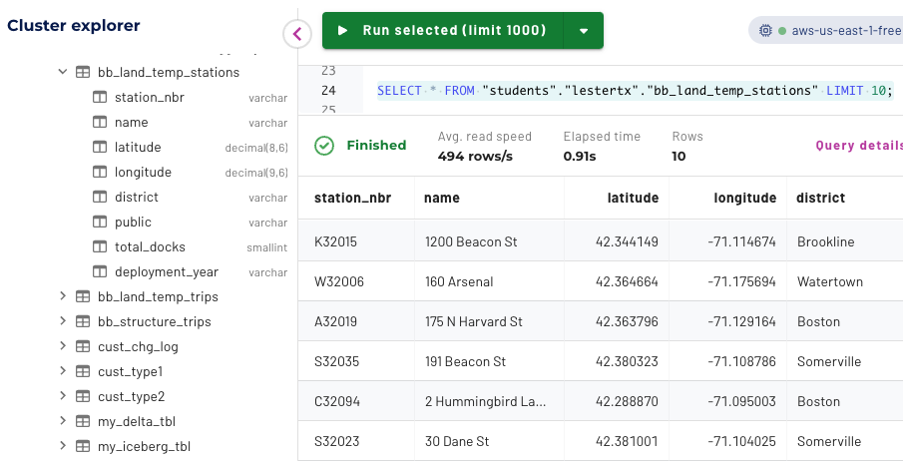

This external table’s location on the data lake is the directory into which the ingestion process will land new data. As we will see later, the underlying data files will be moved into a final resting location within the Land layer along with all previously ingested data after it has been transformed into the Structure layer.

Note: Normally, the external_location property would be a consistent directory, but for future ingestion data, you will recreate the table referencing another location. This is happening as we are not fully automating the end-to-end data pipeline and will not move the temporary ingestion data into its final location.

Step 5 - Transform data types
In practice, a data engineer would work through all columns to check for which datatype would be most appropriate. Then they would perform some inspection of the data present to verify if any particular validity checks need to be implemented and/or if any transformations that are required.

Assume that your research only yielded the following concerns.
- The district column has some empty string values that would be better represented as null values.
- The public column using Yes to indicate a positive value and a boolean data type would be more appropriate.
- The deployment_year column uses N/A in place of null.

Validate the following query resolves those issues.

SELECT
station_nbr, name, latitude, longitude,
nullif(district, '') AS district,
starts_with(public, 'Yes') AS public,
total_docks,
try_cast(
IF(
deployment_year = 'N/A',
'NULL',
deployment_year
) AS int
) AS deployment_year
FROM
bb_land_temp_stations;

Step 6 - Perform initial load to Structure layer
Build a single transformation query by melding together the data conversions/casting efforts along with the enrichment activities. As this is our initial load of the Structure layer table, you can use the Create Table As Select (CTAS) approach to build the table to store this sync-up effort. This table will be used to store high-quality in future instances of this data pipeline you are constructing.

CREATE TABLE bb_structure_stations
WITH (type='iceberg', format='orc') AS (
SELECT
station_nbr, name, latitude, longitude,
nullif(district, '') AS district,
starts_with(public, 'Yes') AS public,
total_docks,
try_cast(
IF(
deployment_year = 'N/A',
'NULL',
deployment_year
) AS int
) AS deployment_year
FROM
bb_land_temp_stations
);

After a cursory review of the new table, validate that the temporary ingestion table has the same number of records as the newly constructed Structure table.

SELECT count() FROM bb_land_temp_stations;
SELECT count() FROM bb_structure_stations;

They both should identify 448 rows present.

To assist the Cost-based optimizer in creating the best possible query plan, calculate statistics on this new table.

ANALYZE bb_structure_stations;

You created an Iceberg table with the ORC file format as you want this Structure layer table to be performance-oriented and transaction capable.

At this point in the pipeline, you would normally move the underlying data lake files from the external_location of the bb_land_temp_stations table to the data lake folder maintaining all the historical raw data received in the past. As this particular table’s future ingestion files will be complete copies of the stations data, the data lake directory location should allow for creating a folder based on the date embedded in the raw file.

No table will be needed, but having the historical raw data allows flexibility should a prior version of the data be needed. You do not have S3 access to make changes, so you will not move the ingest file from its current location.

Step 7 - Simulate an ingestion of delta records
Now that the initial sync-up of the stations table is in the Structure layer, you can focus on building out the pipeline further. New ingest files for stations only include change records (deltas). These changes only address updates to existing stations and the creation of new stations. The output below shows a list of deltas for this table.

Note: To aid in readability and to avoid line-wrapping of these wide records, the “\” character is used to indicate the next line of indented text is still part of the record that started in the first column.

Last Updated,7/4/2022,,,,,,
Number,Name,Lat,Long,District,Public,Total docks,Deployment Year
NEW901,123 Main St,42.3625,-71.08822,District 12,No,22,2022
A32032,Airport MBTA Stop - Bremen St at Brooks St,42.37410288, \
-71.03276432,Boston,Yes,11,2016
C32012,Andrew MBTA Stop - Dorchester Ave at Dexter St,42.33073333, \
-71.05699851,Boston,Yes,0,2013
B32004,Aquarium MBTA Stop - 200 Atlantic Ave,42.35991176, \
-71.05142981,Boston,No,15,2011
A32049,Bennington St at Another St,42.38522394,-71.01063069, \
Boston,Yes,21,2022

Upon review from the original data, you determine there are two new stations and three updated stations.

As identified in Step 3, the pipeline’s ingestion process is being simulated. To accomplish this, drop the temporary ingest table and recreate it with a different external_location value pointing to the incremental ingest data for July 4, 2022.

DROP TABLE bb_land_temp_stations;
CREATE TABLE bb_land_temp_stations (
station_nbr varchar,
name varchar,
latitude decimal(8,6),
longitude decimal(9,6),
district varchar,
public varchar,
total_docks int,
deployment_year varchar
) WITH (
type = 'HIVE', format = 'TEXTFILE', textfile_field_separator = ',',
skip_header_line_count = 2,
external_location = 's3://edu-train-galaxy/bluebikes/raw_stations-2022-07-04_deltas/'
);

Verify that the five delta records are located in the bb_land_temp_stations table.

SELECT station_nbr, name, public, total_docks
FROM bb_land_temp_stations;

Step 8 - Build the pipeline’s MERGE statement
As you are dealing with a list of new and/or updated stations, you need to create a MERGE statement to apply the transformed delta records against.

The statement is broken into five parts. Let’s step through them individually to understand how it works.

After you have reviewed this analysis, assemble & execute the entire query in the Query editor.

Part 1
This initial part identifies the Structure table. This is where the deltas will be merged.

-- merge into the Structure table
MERGE INTO bb_structure_stations
AS base

Part 2
The next part invokes the USING clause. This clause can be used to reference a simple table or the results of some other SQL. In this case, use the transformation query created in Step 5 as the cleaned set of delta records.

-- the contents from the using clause
USING ( -- transform the delta records
SELECT
station_nbr, name, latitude, longitude,
nullif(district, '') AS district,
starts_with(public, 'Yes') AS public,
total_docks,
try_cast(IF(deployment_year = 'N/A',
'NULL', deployment_year
) AS int
) AS deployment_year
FROM bb_land_temp_stations
) AS deltas

Part 3
The next element of the query identifies the criteria necessary for a match between the base table and the list of deltas. For this scenario, this is a simple equality check on the station_nbr table.

-- look for a match on station_nbr
ON (base.station_nbr = deltas.station_nbr)

Part 4
The next section presents the actions that should follow a positive match. In this case, when a match is found, an UPDATE command is used to modify an existing record.

-- if a match then the records needs to be updated
WHEN MATCHED THEN
UPDATE SET station_nbr = deltas.station_nbr,
name = deltas.name,
latitude = deltas.latitude,
longitude = deltas.longitude,
district = deltas.district,
public = deltas.public,
total_docks = deltas.total_docks,
deployment_year = deltas.deployment_year

Part 5
Lastly, you need to account for the false condition and tell the query what to do in such cases. In this case, when a match is not found, then the delta record should be recorded in a new entry. The code below creates that entry.

-- if no match found then add the record
WHEN NOT MATCHED THEN
INSERT VALUES (deltas.station_nbr, deltas.name,
deltas.latitude, deltas.longitude, deltas.district,
deltas.public, deltas.total_docks,
deltas.deployment_year);

Now that you’ve understood how PART 1 - PART 5 work, it’s time to execute them. Combine the SQL from each part into one large query and execute it in your Query editor. You will see a notification similar to the image below, indicating that 5 rows have been changed.
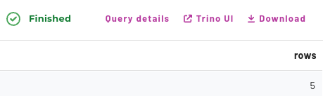

Step 10 - Verify the MERGE logic
Since the Iceberg table format maintains prior snapshots that are queryable via time travel, we can use those as reference points corresponding to each snapshot ID. Using this approach, you will be able to compare the current state of the table with the prior state held in the snapshot.

SELECT * FROM "bb_structure_stations$snapshots";

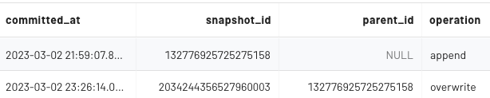

The value of the snapshot_id listed in the first row is the initial snapshot ID.

Using the code below, replace 999999999 with the value that your query returned for the original snapshot.
Note: The value listed in your table will be different from the one listed by the instructor’s table.

SELECT * FROM bb_structure_stations
EXCEPT
SELECT * FROM bb_structure_stations
FOR VERSION AS OF 999999999;

You should see output similar to the image below, listing the 5 rows from the delta ingestion file.

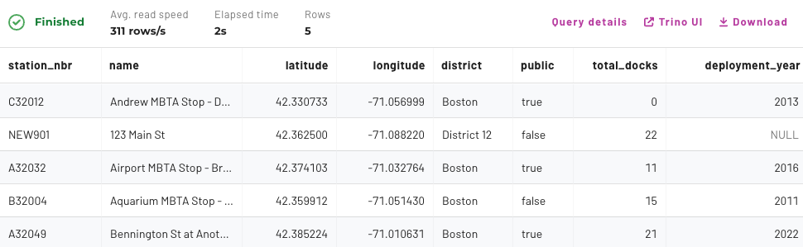

Step 11 - Next steps
Typically, the next step would involve moving the temporary ingestion table’s underlying file to the location of the raw table with all historical information. In this demo environment, you cannot perform this step as you do not have access directly to S3.

Often, in production, the next step might also involve the automation of this pipeline. This would shift away from manual execution and help save time.

END OF LAB EXERCISE

